MOON-1 - UI bootstrap demo

Project: | Moon | Status: | IN PROGRESS
Type: | Story | Priority: | Lowest

Assignee:  Resolution: |  | Reporter:  Votes: | Johan Brodin  0
Labels:  Component/s:  Affects Versions/s:  Fix Version/s: | Important  SaaS  Version One

Descript
This is a HTML description
- Full support of Jira rich text descriptor fields styling


Child Issues
67% Done

MOON-208 | Book meeting with external stakholders |  |  | DONE
MOON-120 | Implement MVP demo | ordify_bellevue | 2023-11-01 | DONE
MOON-7 | Develop wireframes | Support |  | IN PROGRESS

Linked Issues
is blocked by | MOON-5 Implement Capacha | Medium | Done
is mitigated by |  SUP-149 How to get a custom field's name? | Medium | Done
blocks |  SUP-212 Evaluate OKR software | High | Resolved
blocks | MOON-206 Evaluate Asset register | Medium | Done
is blocked by | MOON-474 linked issue | Medium | To Do

Custom Fields
myCascadingList: | first - a
myTextFieldMultiLine (4 renamed): | * First ITem  * Second Iten
Risk severity: | LOW
Risk probability: | Improbable
Risk updated: | 23/Oct/25
Risk impact: | Negligible
Risk updated by: | Johan Brodin
MyWikiMultiField:
Target end: | 21/Feb/26
myMultipleUserPicker: | Johan Brodin
CIA (multi): | Confidentiality, Availability
Risk severity (residual): | LOW
myTextFieldMulti (2 new name): | * first Item  * Second Item
Risk impact (residual): | Negligible
Risk probability (residual): | Improbable
myUserPick: | Johan Brodin
mySelectListSingle: | Value three
mySelectListMultiple: | Value One, Value Three
myText: | my text
myCheckboxes: | Volvo, BMW
myDatePicker: | 05/Aug/24
myLabels: | Important
MyNumbersField: | 1.222
CIA (single): | Availability
myRadioButtons: | ValueOne
myURL: | http://bojaconsulting.com/
Story Points: | 10
Risk score: | 1
Risk score (residual): | 1
End date: | 25/Mar/22
Start date: | 22/Jan/26
myNumberField: | 7

Time
Original Estimate:  Remaining Estimate:  Time Spent: | 1d  64h 0m

Software
Story Points: | 10 | Sprint Name: | Sprint One
Sprint Start Date: | 2019-09-01 | Sprint End Date: | 2020-03-31
Sprint Goal: | Solution MVP | Epic Link: | MOON-16

Attachments
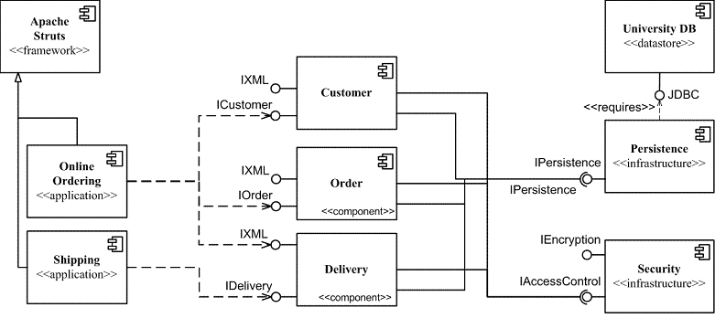

architecture-overview.png

bootstrap.png



example-word.docx



issue-export.pdf

sample_explain.pdf

Work Log |  | User | Time Spent
2019-01-16 | Unknown field: comment | Johan Brodin | 1w 1dh
2022-11-03 | Unknown field: comment | Johan Brodin | 2dh

Comments
Johan Brodin | Created: 23/Oct/25 5:19 PM | Updated: 23/Oct/25 5:19 PM
• Inherent Risk update: HIGH -> LOW
Probability: Probable -> Improbable ---- Impact: Medium -> Negligible
• Residual Risk update: HIGH -> LOW
Probability: Probable -> Improbable ---- Impact: Medium -> Negligible
Johan Brodin | Created: 24/Jul/24 4:30 PM | Updated: 24/Jul/24 4:30 PM
(1) Inherent Risk update: HIGH -> HIGH
Probability: Occasional -> Probable ---- Impact A: Medium -> Medium
(2) Residual Risk update: Unspecified -> HIGH
Probability: Unspecified -> Probable ---- Impact A: Unspecified -> Medium
Johan Brodin | Created: 10/Jul/24 1:22 PM | Updated: 10/Jul/24 1:22 PM
(1) Inherent Risk update: Unspecified -> HIGH
Probability: Unspecified -> Occasional ---- Impact A: Medium -> Medium
Johan Brodin | Created: 07/Aug/23 11:00 PM | Updated: 07/Aug/23 11:00 PM
today comment
Johan Brodin | Created: 11/Jan/22 6:52 PM | Updated: 11/Jan/22 6:52 PM
Inherent Risk update: HIGH -> MEDIUM
Probability: Possible -> Unlikely ---- Impact: High -> Medium
Johan Brodin | Created: 12/Nov/21 12:45 PM | Updated: 12/Nov/21 12:45 PM
Residual Risk update: MEDIUM -> HIGHEST
Probability: Unlikely -> Almost certain ---- Impact: Medium -> Severe
Johan Brodin | Created: 12/Nov/21 12:44 PM | Updated: 12/Nov/21 12:44 PM
Inherent Risk update: HIGHEST -> HIGH
Probability: Almost certain -> Possible ---- Impact: Severe -> High
Johan Brodin | Created: 12/Nov/21 12:40 PM | Updated: 12/Nov/21 12:40 PM
Inherent Risk update: HIGH -> HIGHEST
Probability: Possible -> Almost certain ---- Impact: High -> Severe
Johan Brodin | Created: 22/Oct/21 11:19 AM | Updated: 19/Mar/25 1:31 PM
Image comment
Johan Brodin | Created: 16/Jun/21 12:52 AM | Updated: 16/Jun/21 12:52 AM
Inherent Risk update: HIGHEST -> HIGH
Probability: Likely -> Possible ---- Impact: Highest -> High
Residual Risk update: LOW -> MEDIUM
Probability: Unlikely -> Unlikely ---- Impact: Minor -> Medium
Johan Brodin | Created: 16/May/21 11:35 PM | Updated: 16/May/21 11:35 PM
Inherent Risk update: Unspecified -> HIGHEST
Probability: Unspecified -> Likely ---- Impact: Unspecified -> Highest
Residual Risk update: Unspecified -> LOW
Probability: Unspecified -> Unlikely ---- Impact: Unspecified -> Minor
Johan Brodin | Created: 06/Jun/19 11:04 PM | Updated: 06/Jun/19 11:04 PM
Please review design

