OKR by BOJA Documentation Home

Document revision v24

22 October, 2026
Table of Contents
1 Getting Started 7
1.1 Jira Edition 7
1.2 Confluence Edition 8
1.3 monday.com Edition 10
1.4 Web Edition 10
1.5 Online Demo 11
2 Workspace 12
2.1 Workspaces Manager 12
2.2 Create Workspace 13
2.3 Private Workspace 14
3 OKR 15
3.1 User Home 15
3.2 OKR Views 16
3.3 OKR Progress - Manual Mode 18
3.4 OKR Progress - Automatic Mode 19
3.5 OKR Weight 24
3.6 OKR Custom Fields 26
3.7 Align & Assign OKRs 26
3.8 Yearly Company OKRs 30
3.9 External Links 31
3.10 Restore OKR 32
3.11 Jira Features 33
3.12 monday.com Features 35
4 Explore 37
4.1 Follow OKRs 37
5 Roadmap 38
6 Dashboard 39
7 Reports 40
7.1 Performance Report 40
7.2 Alignment Report 41
7.3 Custom Report 42
7.4 User Report 43
8 Confluence 45
8.1 1. Connect Jira App to Confluene 45
8.2 2. Add to Confluence Pages 45
8.3 3. Examples 46
9 Settings & Permissions 48
9.1 Settings Manager 48
9.2 Notification Manager 51
9.3 Status Manager 52
9.4 Period Manager 52
9.5 Label Manager 53
9.6 Custom Field Manager 54
9.7 Permissions 55
10 User Management 59
10.1 Jira - User Management 59
10.2 monday.com - User Management 59
10.3 Web - User Management 59
11 Security and Privacy 62
12 Miscellaneous 63
12.1 OKR by BOJA Jira Pro Version 63

OKR by BOJA for Web, Jira, Confluence and monday.com enables users to create, align and execute on common goals. It’s an enterprise OKR solution developed from the ground up supporting a 4000 person company. Please see below the key solution principals (getting started)
Design principals | Description
Affordable | All users within companies to have access.
Flexible | Full support tailoring to different OKR processes not the other way around
Powerful | The app must offer a complete OKR solution feature set driving full user value
Secure | Enterprise security and privacy. Companies must trust the security architecture
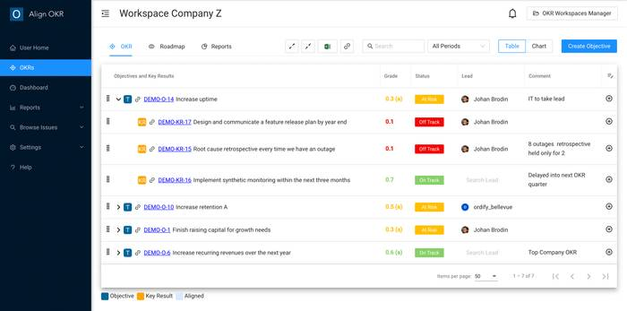
Excel like Way of Working
Fully configurable OKR table. Inline editing, change order, user columns or swap in default ones, export to CSV and Excel
Align and Assign OKRs
Align and assign OKRs between company, group, team, personal with full support for multiple OKR alignments
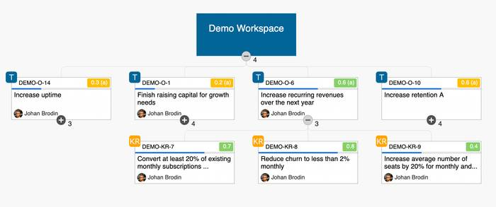
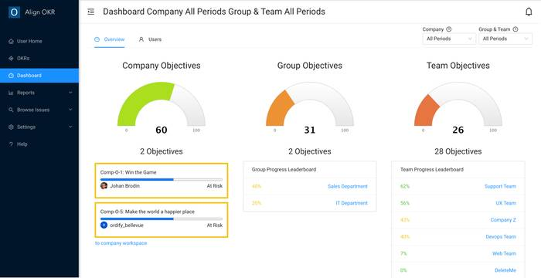
Dashboard
Quickly see OKR status and take actions
Multiple Reports
Drive visibility with multiple reports such as performance, alignment, custom and user. Clickable down to individual OKRs for editing
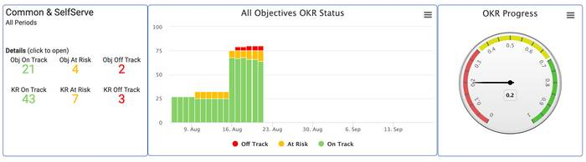
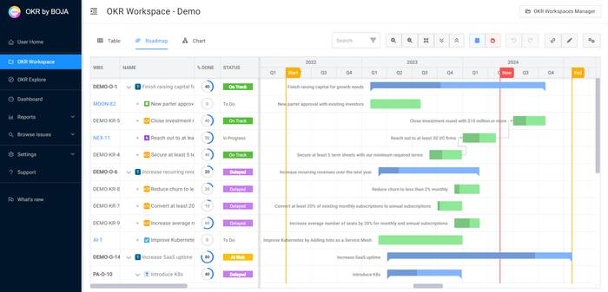
OKRs on Gantt Roadmap
Visualize OKRs roadmap on gantt chart with dependencies

Getting Started
OKR by BOJA comes in both a Jira cloud, monday.com and web edition.
- Jira Edition
- Confluence Edition
- monday.com Edition
- Web Edition
- Online Demo

Jira Edition

Launch from Jira Apps menu
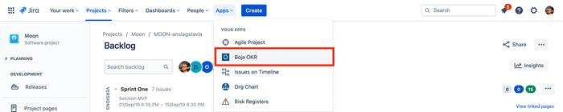

Launch from a Jira Board
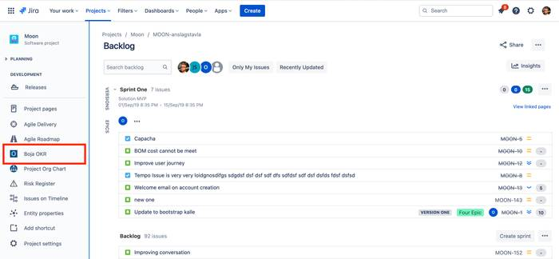

Confluence Edition
BOJA OKR for Confluence app is an extension to “BOJA OKR for Jira”. It adds three Confluence macros.
- Add OKR Macro to Confluence Page
- OKR Workspace
- OKR Performance Report
- OKR Dashboard

Add OKR macro to Confluence page
Three macros are available after installation: OKR Workspace, OKR Dashboard and OKR Report.
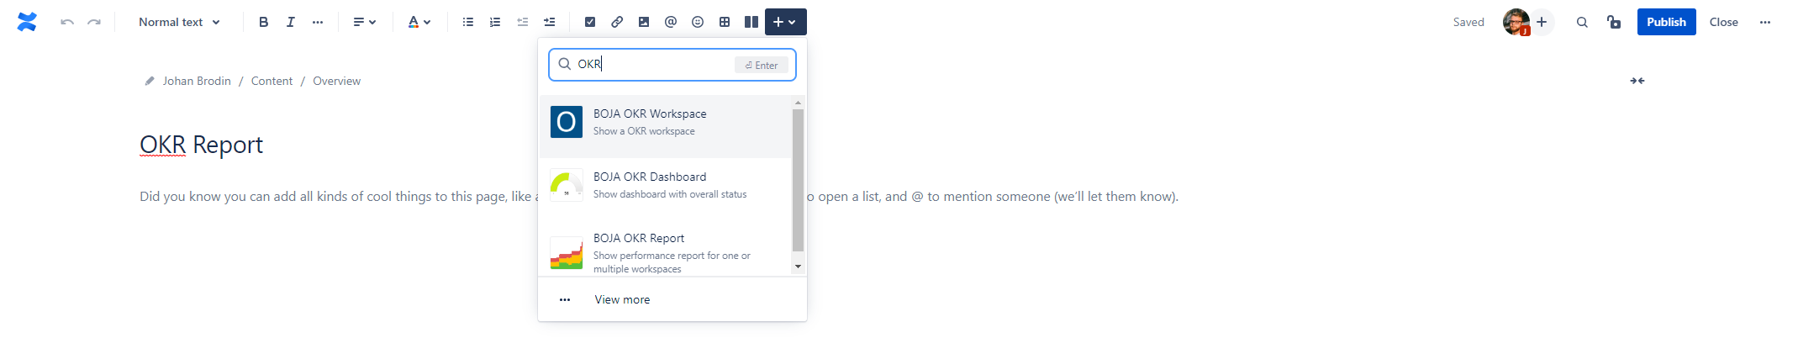

OKR Workspace
Show your OKR workspace inluding timelines on Gantt on Confluence pages.
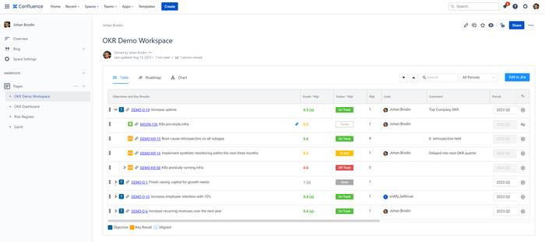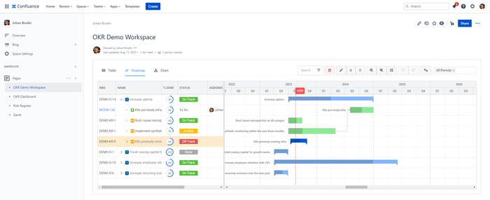

OKR Performance Report
Performance report to one or multiple Workspaces. Drill down to individual OKRs and take actions.
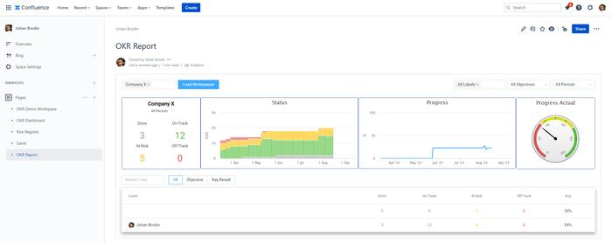

OKR Dashboard
Dashboard with company, group and team status. Quickly see the overall picture and take actions.
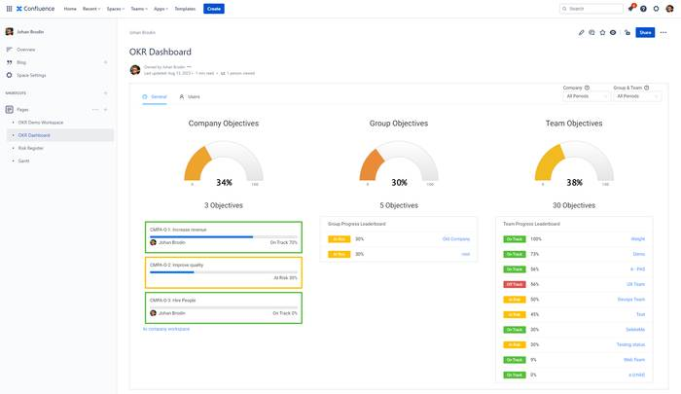

monday.com Edition
TBD

Web Edition
Getting started is straight forward with easy signup of new companies and adding users
- Sign up your company at bjaokr.io
- Add users

Sign up your company at at bojaokr.io
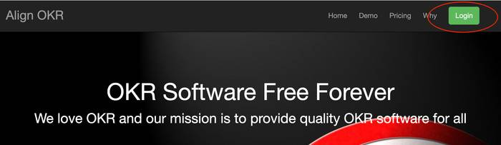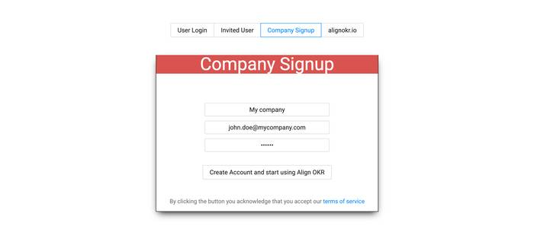

Online Demo
If you want to try Boja OKR without signing up no problem! Take a look at our online demo

Workspace
Boja OKR centers around workspaces. A workspace can be of type company, group, team and personal. Each workspace has a permission scheme, lead person and unique key. A personal workspace can be public or either public or private to the user.
OKR objective and key results are then added to to different workspaces. This can be done in a fully customisable table working like in Excel or in a graphical chart view. On Jira cloud Jira Issues can be linked to both objectives and key results.
Finally Objectives in different workspaces can be aligned (upstream). This means that a team can align its objective to both a group as well as a company objective. Key result can also be assigned (downstream). This means that a manager can assign one of his key result to an employee or team for them to work on.
- Workspace Manager
- Create Workspace
- Private Workspaces

Workspaces Manager
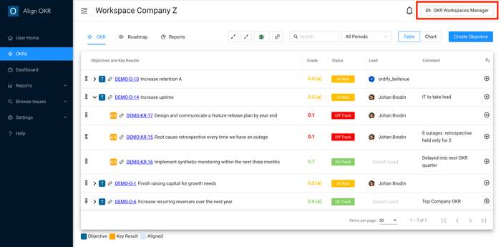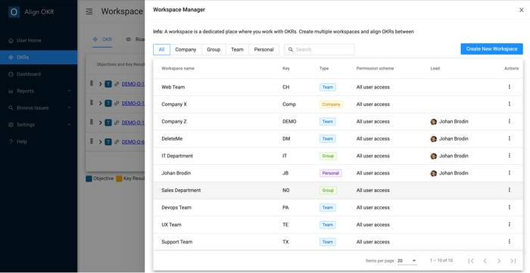

Create Workspace
Press the right top “Create New Workspace“ button
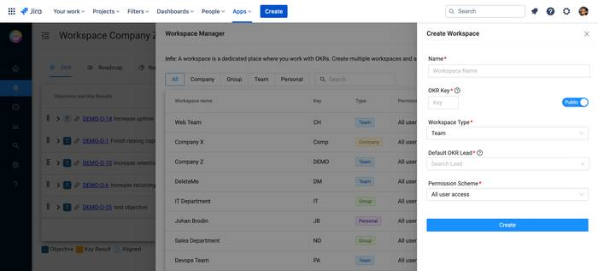

Private Workspace
In private workspaces only the person who created the workspace can open and view the OKRs. That person can also invite collaborators with full access.
Please note that admins can delete and change name of private workspaces but have no access to the OKR data itself.
Limitation
OKR data in private workspaces are restricted in the user interface and not in the database layer. So trusted logged in users might with “hacking“ and direct API calls get access. Please, put truly sensitive information as Jira issues linked to OKRs which are fully protected.
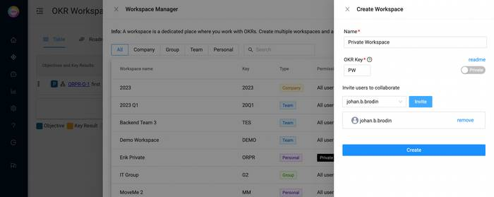

OKR
The solution supports both a customisable table view as well as a Chart view working with OKRs
- User Home
- OKR Grade & Status
- OKR Table View
- OKR Chart View
- Align & Assign OKRs
- External Links
- Restore OKR
- Jira Features
- monday.com Features

User Home
Quickly see all user assigned OKRs with engagement report and take actions on those in user home. There are also quick links to the company, user personal and configurable workspaces.
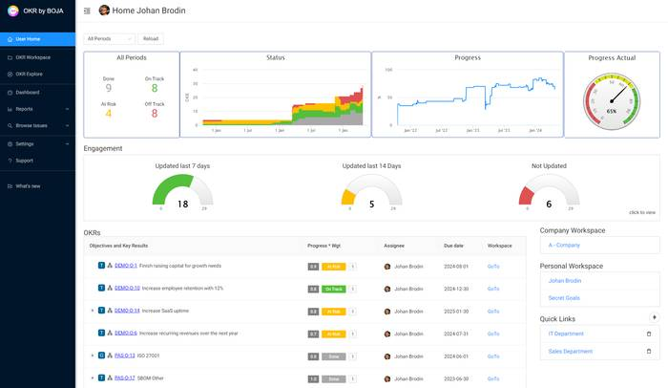

OKR Views
- OKR Table View
- OKR Roadmap View
- OKR Chart View

OKR Table View
Work with OKR as in an Excel table… Edit OKRs inline, drag & drop rows, add & delete OKRs, expand & collapse, search for OKRs, export to Excel and select Period.
- Customise Table Columns
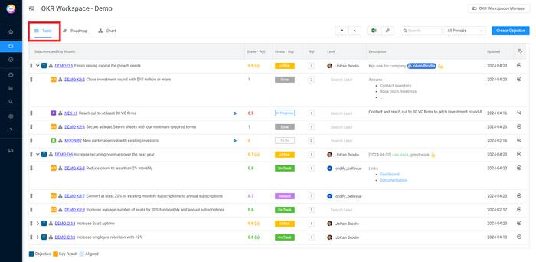

Customise Table Columns
Press the top right table column manager icon or select “Column Manager“ in settings. Changes are saved within the workspace and are shared with all using the workspace.
Create new columns, enable & disable and swap column order. Column width is set by drag & drop directly in the table.
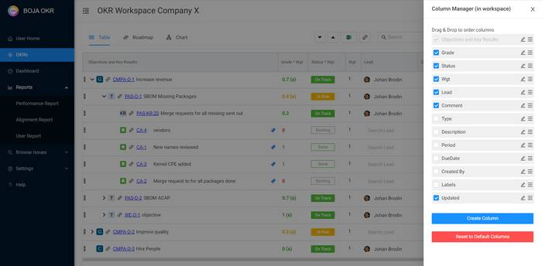

OKR Roadmap View
Visualise OKR timelines on best Gantt chart available from Bryntum
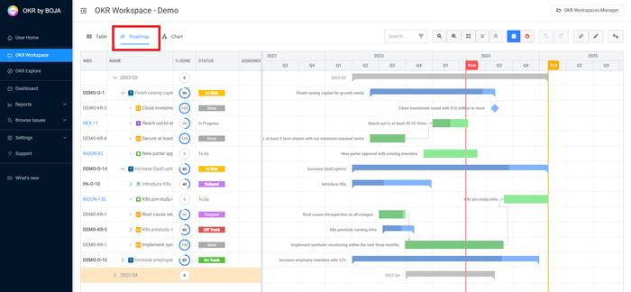

OKR Chart View
The solution also supports working with OKRs in a graphical chart view. Toggle between table and chart in the top right switcher.
Click on OKRs to edit, view objectives or all OKRs, expand & collapse, zoom in & out and export to image.
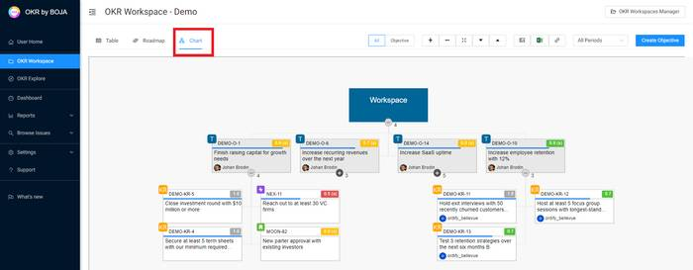

OKR Progress - Manual Mode
OKRs and linked items (Jira, monday.com) progress can be set manually by users or automatic by OKR by BOJA. All can be toggled between manual and automatic mode and this page focus on the manual mode.

Grade & Status
Grade and status are set in the detail drawer or directly in the OKR table. OKR by BOJA supports the grade types Google, percent, binary and number. It enables users to fully map and track progress toward goals.

Progress in detailed drawer
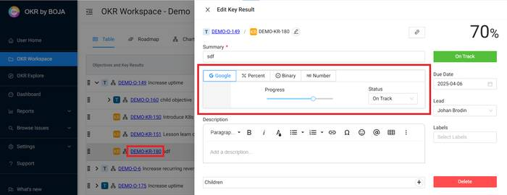

Progress in OKR table
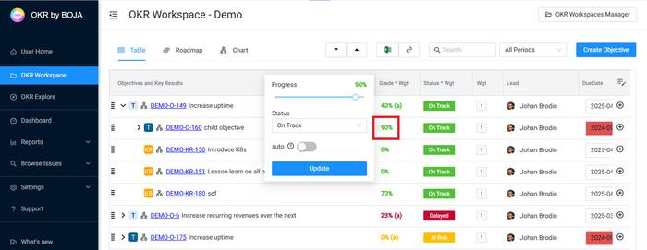

Status types
OKR by BOJA comes with pre-defined status “On Track“, “At Risk“, Off-Track and Done. Create and manage statuses in the status settings manager.

OKR Progress - Automatic Mode
OKRs and linked items (Jira, monday.com) progress can be set manually by users or automatic by OKR by BOJA. All can be toggled between manual and automatic mode and this page focus on the automatic mode.
Automatic Mode
- Calculation OKRs with children
- Calculation linked Jira issues
- Calculation linked monday.com items
- OKR Threshold auto Status (grade & due-date)

Automatic Mode
In automatic mode (auto) the solution calculates grade and status automatically based on child items grade and status. Example of child items are key results or linked Jira and monday.com items.
All items can be toggled between manual and auto mode. In the OKR table auto items have a post-fix (a) in the grade column.

Toggle between manual and auto progress mode
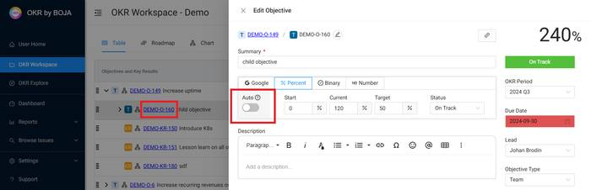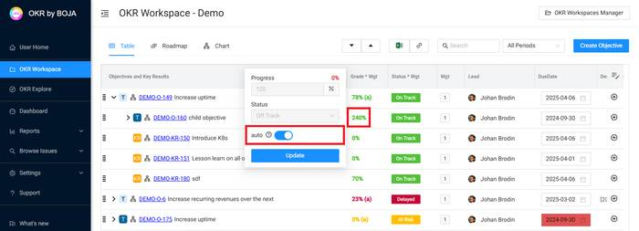

1. Calculation OKRs with children
Grade calculation
- Rounded average of all child grades
Status calculation
- All statuses has a status category with a numeric value
  - 1 (on-track, done), 2 (at-risk), 3 (off-track)
- Status values from the children are summed up
- Then the total value is divided with num children and finally rounded to either 1, 2 or 3
  - As an example 2 on track and 1 at risk has a total status value of 4. That divided with number of OKRs which is 3 in this case is 1,33. Rounded to the closest integer is 1 which is status on-track.
- Finally if all children have the done status category the OKR is assigned to the done status

2. Calculation linked Jira issues
Jira issues can be linked to both objectives and key results. The auto calculation for both grade and status are configured in the settings manager (see below)
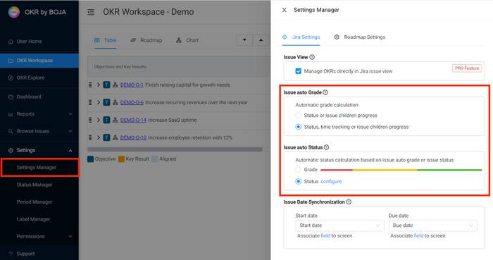

Issue auto Grade
Issue | Grade (progress)
Issue in a Jira done status | 1
Epics issue (in-progress status)  - An Epic with 10 child issues with 7 done has the grade 0.7 | Jira Epic progress
Issue with sub-tasks  - An issue 4 sub-tasks where 2 are done has the grade 0.5 | Jira issue progress
Issue with time tracking (picture below) | Jira time tracking progress
All other issues | 0
Example: Issue with time tracking
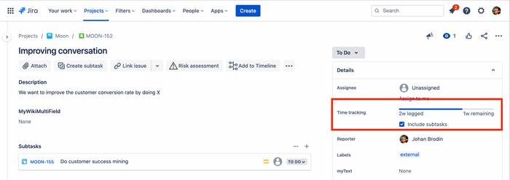

Issue auto Status - based on issue grade (option 1 in settings manager)
Grade (progress) | Status
0% - 19% | Off Track
20% - 59% | At Risk
60%-99% | On Track
100% | Done

Issue auto Status - based on Jira status mapped to OKR status (option 2 in settings manager)
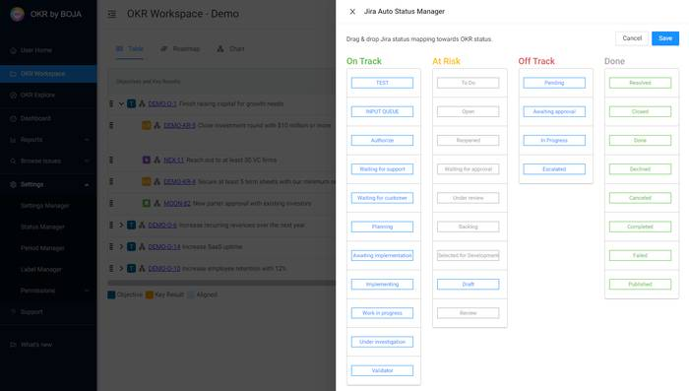

3. Calculation linked monday.com items
Item grade and status are calculated according to below. Progress of items with sub-items are calculated based on the sub-items. All items can be switched between manual and automatic progress mode.
Grade calculation
Items | Grade (progress)
Number of done status columns divided with all status columns | 0% - 100%  (1 done with 4 status columns is 25%)
Items without done columns | 0
Status calculation
Grade (progress) | Status
0% - 19% | Off Track
20% - 59% | At Risk
60%-99% | On Track
100% | Done

4. Calculation OKR auto Status (grade & due-date)
In OKR auto Status users cannot set status manually. Progress status is automatically calculated based on grade and time left to item due date configured in the settings manager.
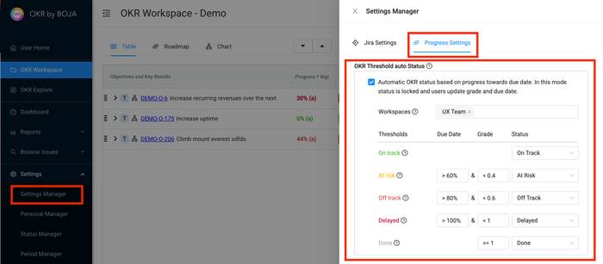
Example Calculation
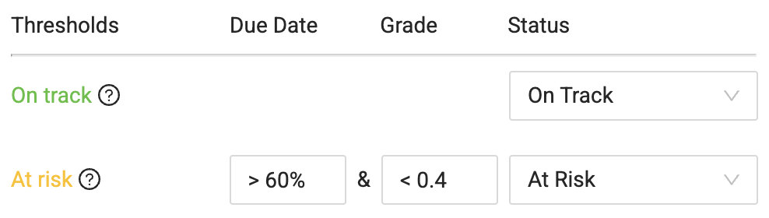 | Example  If more then 60% of task duration has been consumed, and if grade is less then 50%, then set status At Risk
OKR Threshold auto Status.mov

OKR Weight
OKR weight allows users to mimic that some OKRs are more important then others. Default weight is one (1) and are set on all items. They are used auto calculating parent progress.

Set weight - option 1
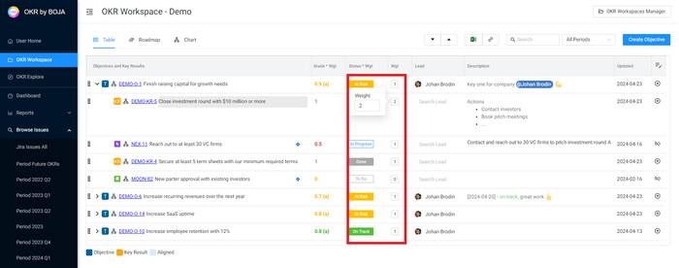

Set weight - option 2
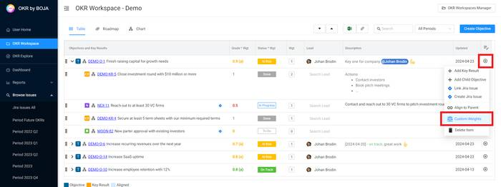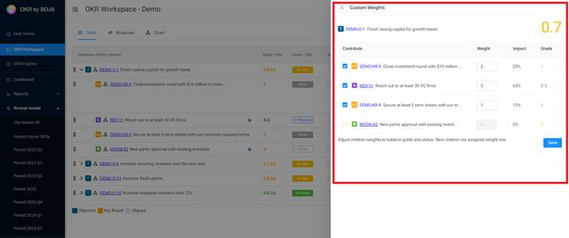

Set weight - option 3
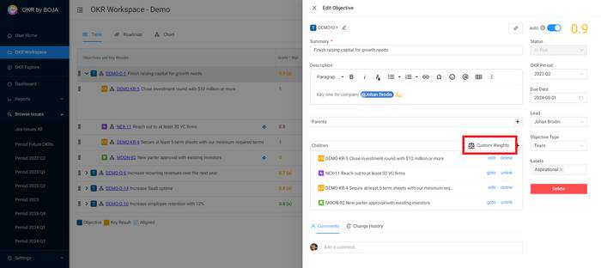

OKR Custom Fields
Custom fields extend OKR by BOJA with company specific editable fields. Fields are injected directly in OKRs, Jira issues, monday.com items as well as columns in the OKR table. Create and manage them in settings.

Custom Fields in a OKR
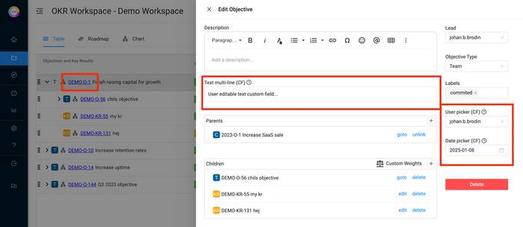

Custom Fields in OKR table (add in column manager)
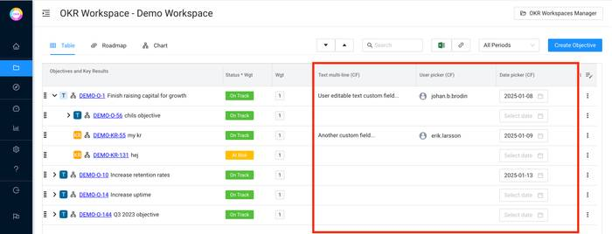

Align & Assign OKRs
Align and Assign OKRs to other workspaces with a few clicks. Then use the graphical alignment view to see the bigger picture on how OKRs are aligned to other ORKs and overall goals.
As one of few solutions Align OKR supports multi OKR alignment and assignments. As an example this means that a team can align its OKRs both to the department as well as company OKRs (upstream). And that a manager can assign dedicated key result to individuals or teams (downstream)
- View Alignments
- Align Objective (upstream)
- Assign Keyresult (downstream)

View Alignments
Click the OKR align icon to view how the OKR is aligned to OKRs in other workspaces.
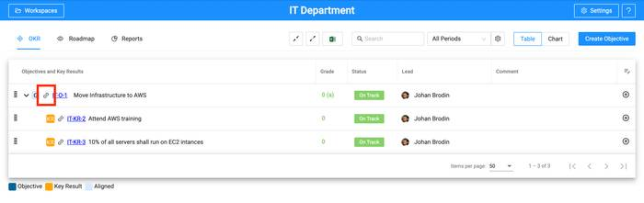
The selected OKR is highlighted with a red box. Below you can see how the IT Department “Move Infrastructure to AWS” Objective (IT-O-1) is aligned to the “Increase Uptime” Objective (DEMO-O-14). Switch between viewing only objectives and including key results.
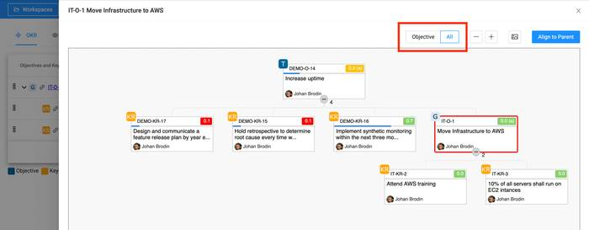

Align Objective (upstream)
Objectives can be aligned to other objectives or key results in two ways.
- Press the objective identifier link and then the parents plus button.
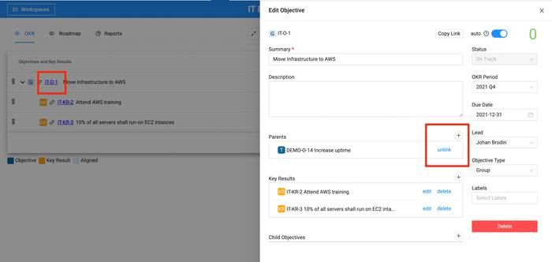
- Or press press the objective alignment icon and then “Align to Parent“
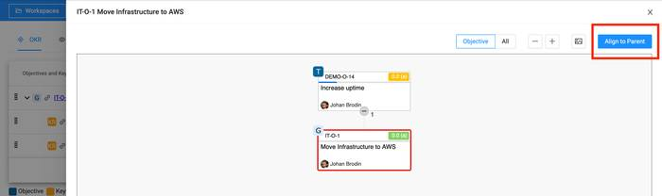
Then select the target workspace (can be both a remote workspace and the active one). Finally select the objective or key result you want to align to.
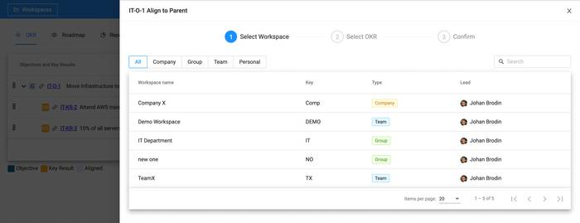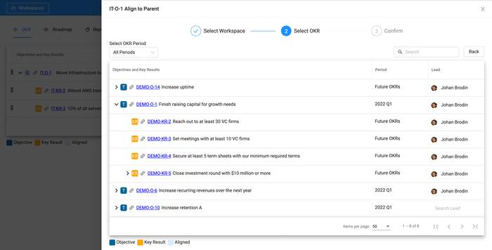

Assign Keyresult (downstream)
A key result can be assigned to another workspace. In that workspace a new objective will be created aligned to the assigned key result.
The typical use case is to assign key results from top workspaces to team or personal workspaces. That can be a manager assigning to employees or departments to various teams.
- Press the key result alignment icon and select “All “to see the key results (Objective/All switch)
- Press the “Assign to Workspace“ button
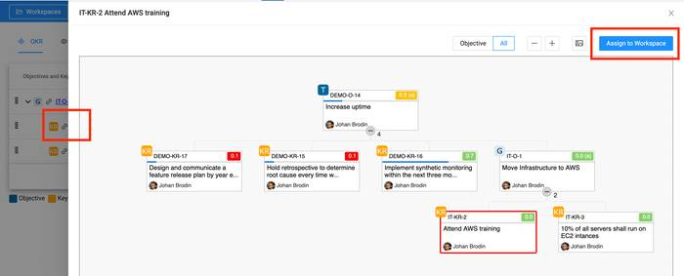
- Finally select the workspace to assign the key result to
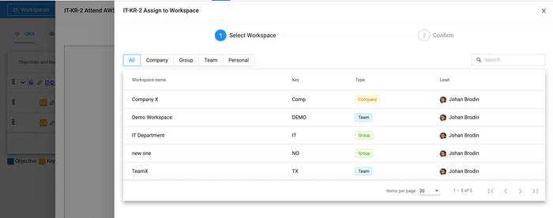

Yearly Company OKRs
Yearly company OKRs with group, teams and individual working on a quarterly OKR cadence is best practice. Boja OKR fully support this way of working!
- Company Workspace
- Group/Team/Personal Workspace
- Reporting Yearly OKRs

Company Workspace
- In the OKR period manager create a yearly period e.g. 2023 (your Jira admin)
- In your company workspace create OKRs with the period 2023
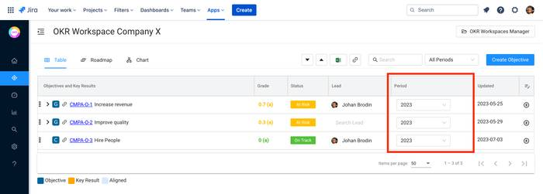

Group/Team/Personal Workspace
- In the OKR period manager create a quarter period e.g. Q1 2023 (your Jira admin)
- In the child group/team/personal workspace create OKRs with the period Q1 2023
- Align those OKRs to the relevant company 2023 OKRs

Reporting Yearly OKRs
In the performance report select the previous company workspace and period 2023. Then all OKRs including the aligned child workspace OKRs are shown. This is a very powerful view to keep track of how overall OKR status are trending toward the company objectives.
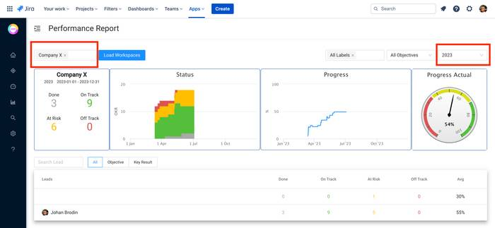

External Links
Quickly copay and share links to OKRs, workspaces and roadmaps. There are multiple link icons throughout the solution copying the link to clipboard.

Examples
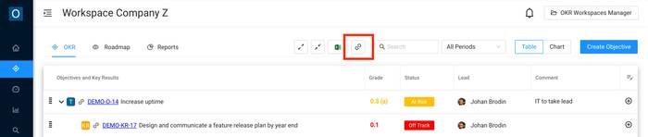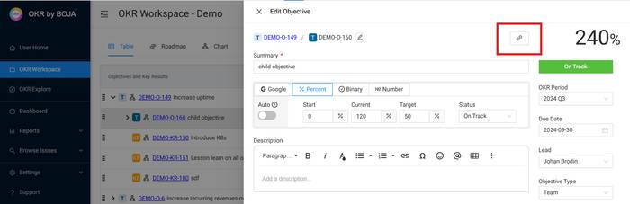

Restore OKR
Deleted OKRs can be restored from bin. Restoring OKRs with child key results or child okrs also restore all children.
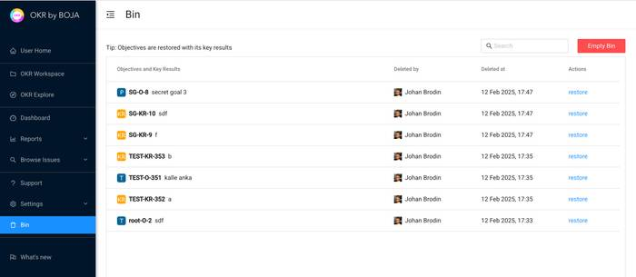

Jira Features
OKR by BOJA integrates seamless with Jira
- Link Jira issues to OKRs
- Linked Jira issues searchable with JQL
- OKRs in Jira issue view
- Issue auto status and auto grading
- Issue dates synchronization to roadmap

Link Jira issues to OKRs
Jira Issues can be linked to both Objectives and Key results. You can link one Jira Issue to multiple OKRs however only one in a workspace. Please press the plus button to the right on the OKR row. Then either link an existing Jira Issue to that OKR or create a new one.
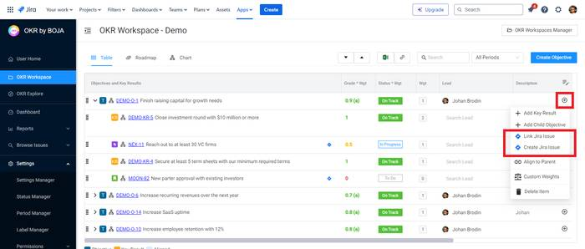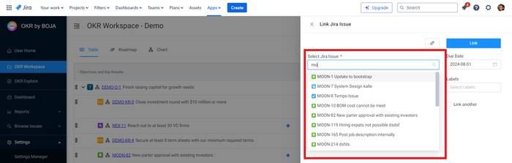

Linked Jira issues searchable with JQL
All linked issues are searchable wit JQL with quick link as highlighted in the picture
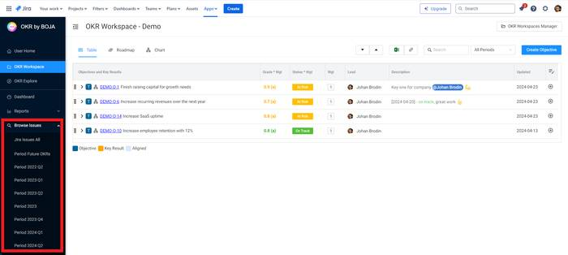

OKRs in Jira issue view
In “General Settings” please set “Show OKRs in Issue View“. All OKRs that the Issue is linked too is then showing up on the Issue view right panel. Clicking on any of those OKRs takes the user directly to the OKR in the app.
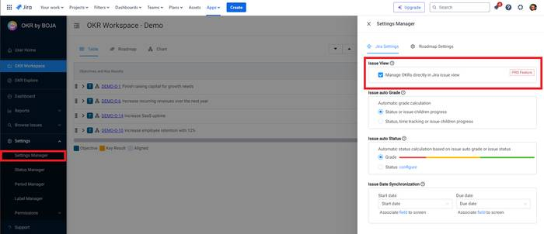
Detailed Issue view
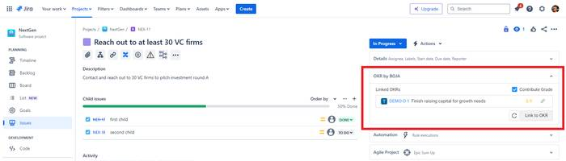

Issue auto status and auto grading
settings

Issue dates synchronization to roadmap
settings

monday.com Features
Link monday.com items to OKRs
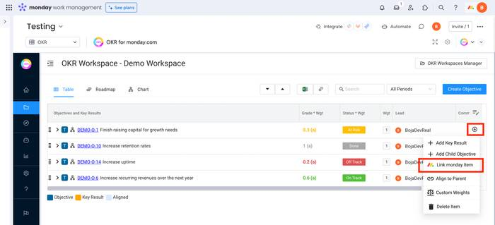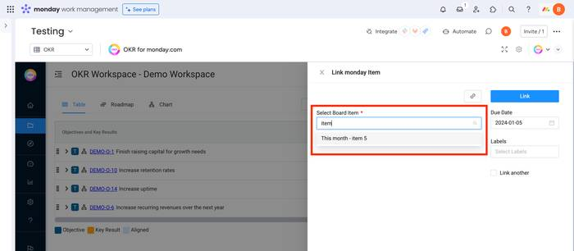

Explore
Explore all OKR in one place. Quickly search and find OKRs among all available ones. Edit grade, status and weights directly in the explore table or jump to OKR workspace.
- Follow OKRs
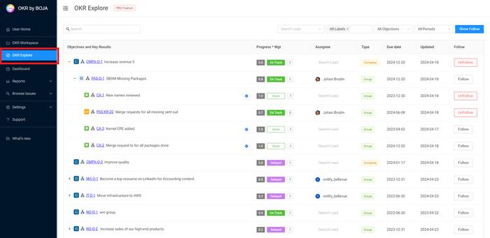

Follow OKRs
In the explore table users can mark and follow individual OKRs. Followed OKRs are available as:
- Follow OKR filter directly in the OKR table
- Follow OKR custom report
- Follow email notifications on OKR updates configurable in settings
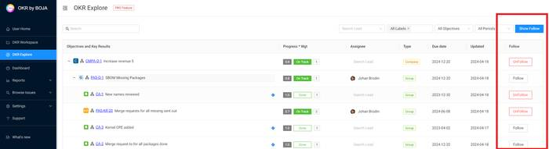

Roadmap
Visualise OKR timelines on best Gantt chart available from Bryntum

Dashboard
The dashboard shows the grade and status for all company, group and team workspaces. Top right there are two period pickers. One for the company workspace and one for the groups and teams. Normally company OKRs has a cadence of one year with group and teams quarterly.
Quickly take actions:
- Click on a workspace quick link. Then view and edit ORKs in the OKR table view.
- In dashboard users menu. OKRs are directly shown and editable grouped by assignee and status.
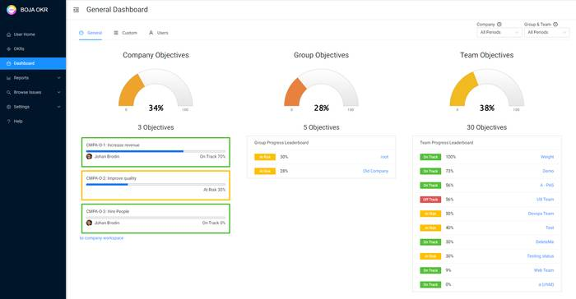
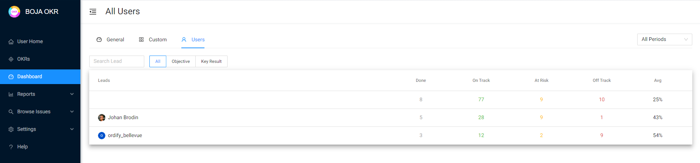

Reports
In reports the user can select any combination of workspaces, filter on labels, periods and users. It is fully clickable down to individual OKRs supporting editing also in report mode. At the moment two reports are supported.
- Performance Report
- Alignments Report
- User Report

Performance Report
The performance report is build to give you instant visibility on your OKR performance now and over time. You can select any combination of workspaces, users, labels and periods and its clickable down to individual OKRs.
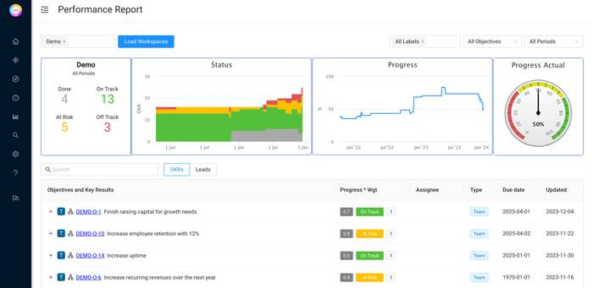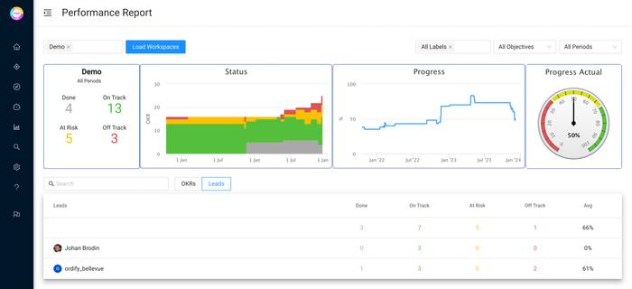

Alignment Report
The alignments report enable you to easily keep track on how many of the selected workspace OKRs have been aligned by other workspaces. Looking at the Company OKRs it then easy to see which of the Objective and Key Result other teams have picked up and are working on.
The below report shows that out of 21 OKRs in the demo workspace only 3 have been aligned to (inbound link)by other teams or persons (workspaces).
The Treeview in the same report also shows that the linking has been done to 3 key results and all of them is having the objective “Finish raising capital for growth needs“
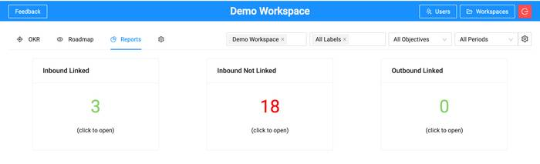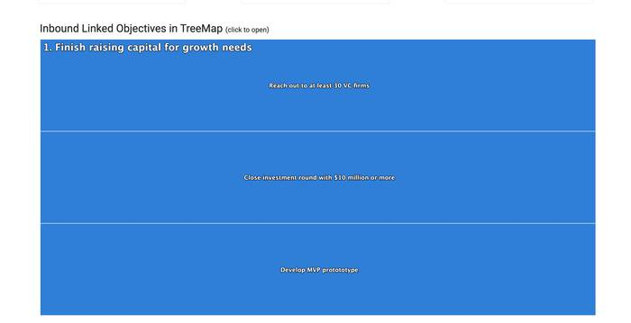

Custom Report
Create custom reports consisting of any combination of Objectives and/or OKR workspaces.
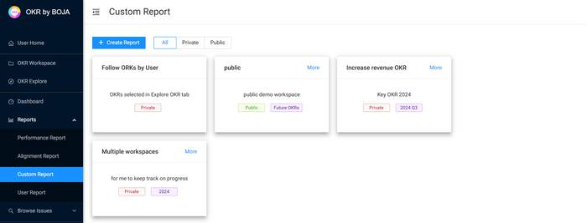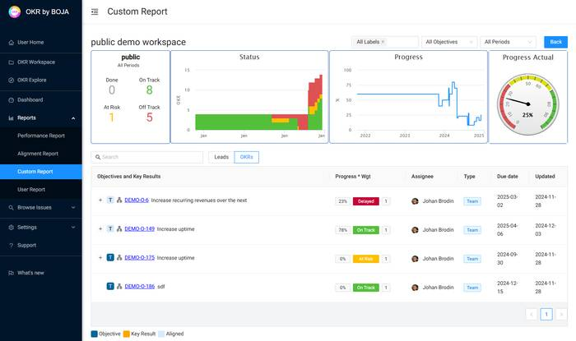

User Report
Select users and get a user report with all OKRs assigned. OKRs are editabled from within the report.
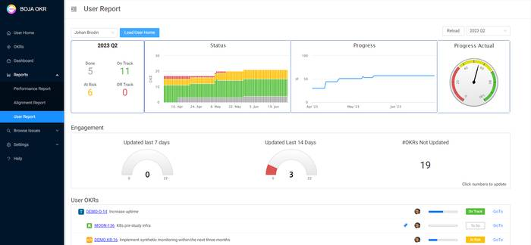

Confluence
OKR by BOJA supports both Jira and Confluence within a single app, all powered by the same shared data. Anything you can do in Jira, you can also do seamlessly in Confluence.
- Connect Jira App to Confluence
- Add to Confluence Pages
- Examples

1. Connect Jira App to Confluene
At app installation connect the app to both Jira and Confluence. This can also be done after installation according to below.
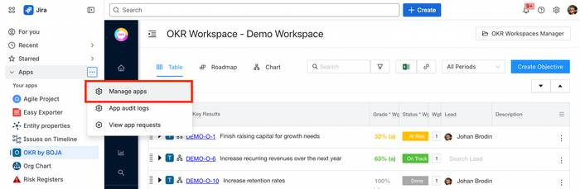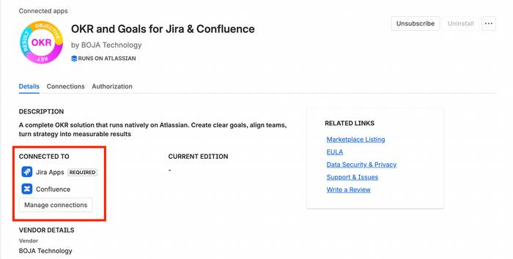

2. Add to Confluence Pages
Easily add OKRs with BOJA using the OKR macro. It’s fully editable in Confluence, and the data seamlessly syncs with the Jira app.
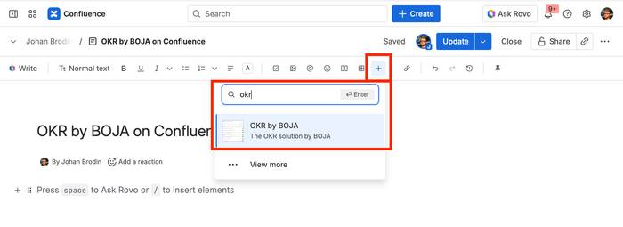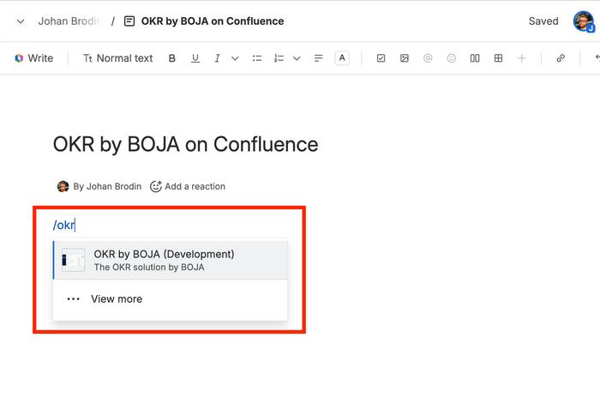

3. Examples
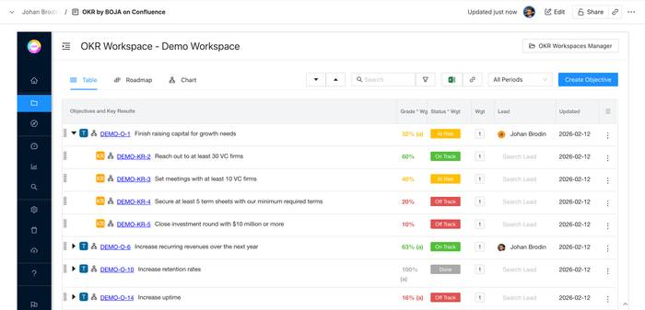

Settings & Permissions
- Settings Manager
  - Jira Settings
  - Progress Settings
- Notification Manager
- Status Manager
- Period Manager
- Label Manager
- Custom Field Manager
- Permissions
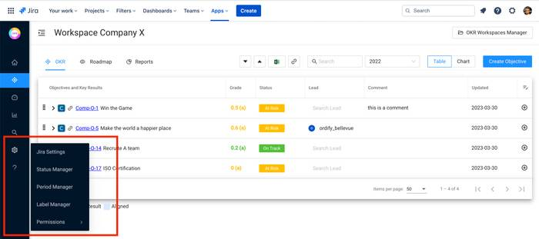

Settings Manager
Configure how Jira is integrated into OKR by BOJA as well as general progress settings.
- Jira Settings
- Progress Settings

Jira Settings
OKR by BOJA comes with a rich set of Jira configuration.
- Issue View
- Issue auto Grade
- Issue auto Status
- Issue Date Synchronization
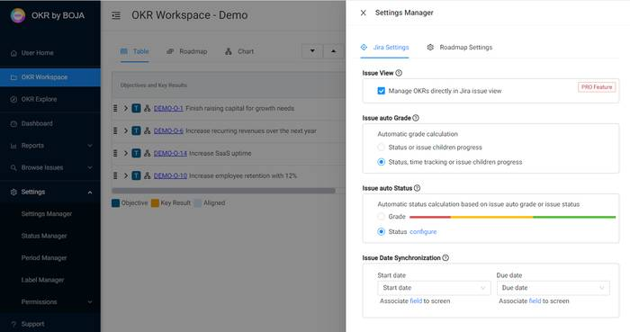

Issue View
Manage OKRs directly from the Jira issue view
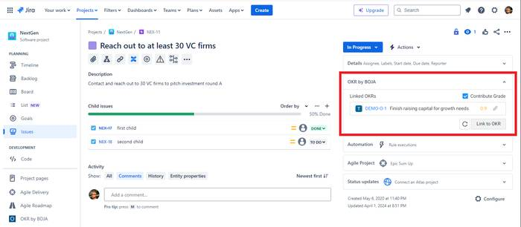

Issue auto Grade
Linked Jira issues can be set to auto or manual grading. In manual mode the user grades progress manually between 0-1. In auto mode grading is done based on issue status, child progress and time tracking.
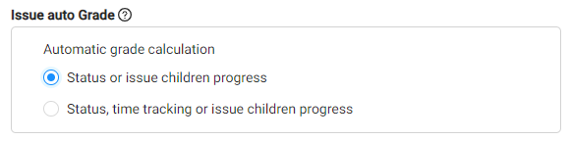

Issue auto Status
Linked Jira issues can be set to auto or manual status. In manual mode the user sets OKR status manually and in auto mode status is automatically calculated based on issue auto grade or status.
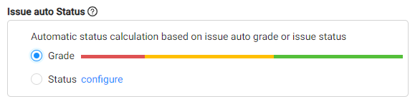
Option 1: Status based on grade: 0-20% off track, 20-60% at risk, 60+ on track
Option 2: Map Jira status to OKR status

Issue Date Synchronization
Synchronize solution start & due date fields used in e.g. roadmap with Jira date fields
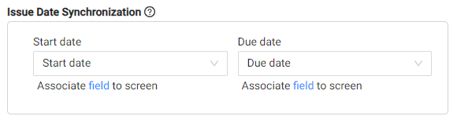

Progress Settings
OKR by BOJA can be configured to automatically set status based on grade and progress towards due-date. The recommended way to update due-date is by drag & drop in the roadmap however it can also be updated the due-date field.

Threshold auto Status
Automatic status updated based on schedule and progress. Configure grade and due-date thresholds and map them to OKR statuses. If thresholds are passed the status is automatically updated for both OKRs as well as linked Jira and monday.com issues. Please note that in this mode status is locked and cannot be updated manually.
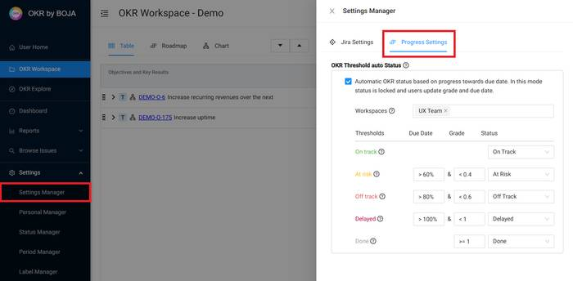

Notification Manager
Users can individually configure email notifications on OKR activity. Notifications are only in the Jira edition.
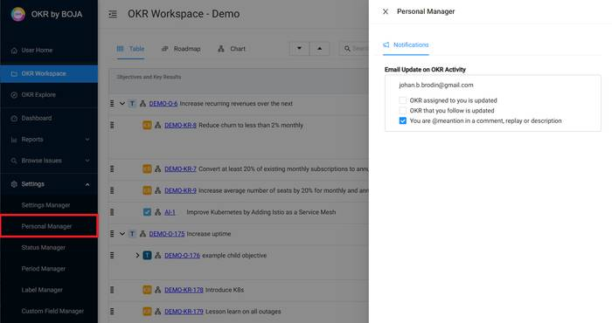

Status Manager
Create, delete and edit OKR statuses and use within all workspaces.
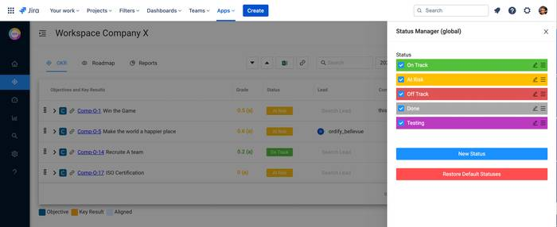

Period Manager
Periods are created and managed in the settings “Period Manager“. All OKRs belong to one period and the recommended way of working is to have quarterly periods with company OKRs having yearly. The solution also provides two (2) static periods “All periods“ and “Future OKRs” available in period pickers.
Archive periods to improve performance
When loading a workspace, all OKRs with active period are loaded. If there are linked active OKRs those remote workspaces are also loaded. OKRs with archived periods are not loaded.
To improve load speed and overall solution performance we recommend to archive old periods.

Active periods are global and can be used throughout the solution.

Access to the period manager can be configured in the permission manager.

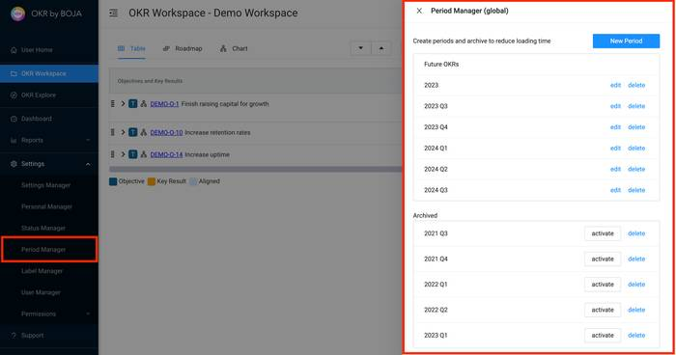

Label Manager
Create labels then assign them to OKRs. Labels can be viewed as tags and are created and managed in the “Labels Manager”. Typical types of labels are OKR commitment levels e.g. Committed or Aspirational. Labels are used throught the solution to drive visibility and focus e.g. as filter in reports.
Labels are global and can be used throughout the solution.

Access to the period manager can be configured in the permission manager.

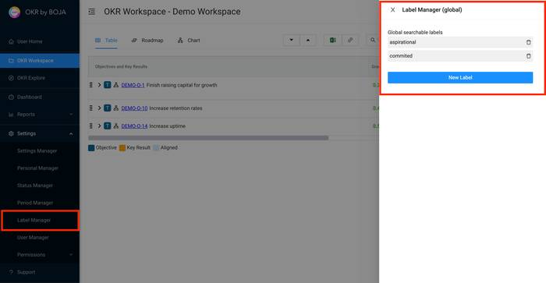

Custom Field Manager
Create custom fields and add to OKR, Jira issues and monday.com tasks. This is a powerful feature enabling companies to add editable company data fields into the OKR by BOJA solution (more info).
Current custom fields types (on request we are happy to add more)
- Text multi-line
- User picker
- Date picker
- Rick text (HTML) - planned
- Jira custom field - planned
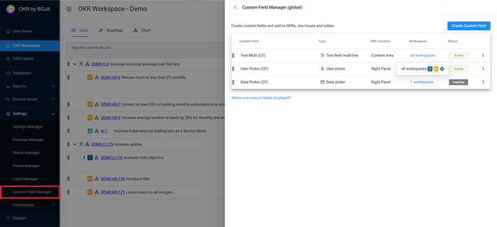

Permissions
Align OKR has a rich set of permissions controlling both user, workspace and OKRs rights.
- User Access
- User Admin
- Permission Manager
- OKR Workspace Permission Scheme
- Permission Limitations (readme)

User Access
- Jira edition - Users with Jira Global Permission “OKR by BOJA Access“ can launch the add-on.
- Web edition - All users invited
- monday.com - All users except viewers
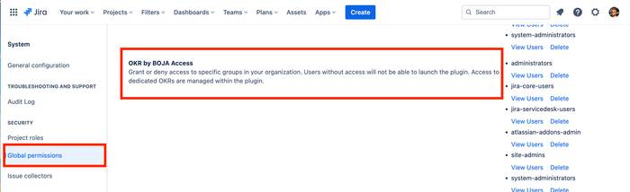

User Admin
Admin users differs between the web and Jira edition.
- Jira edition - Users with Jira global permission “OKR by BOJA Administrator“ (limitations)
- Web edition - All users with the role admin
- monday.com - monday.com admins
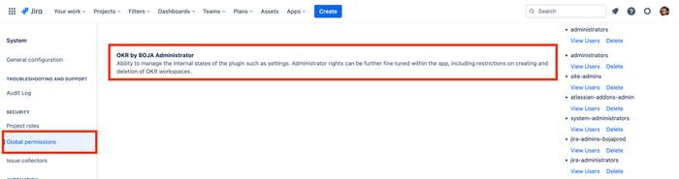

Permission Manager
Restrict or grant actions such as “delete workspace” to admins or all users.
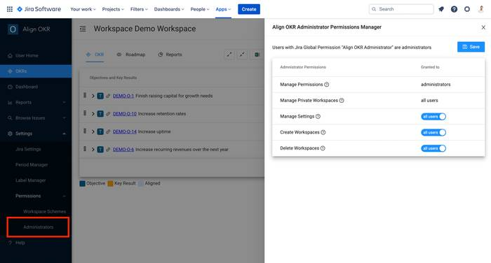

OKR Workspace Permission Scheme
Create workspace permission schemes and assign too workspaces. Schemes enable full control over who can view and edit workspaces as well as view, edit and delete permissions to individual OKRs. The “all user access“ scheme is the default scheme creating workspaces.
Private workspaces can only be accessed by the creator and persons invited by the creator. Admins can manage private workspaces such as delete however not view the data.
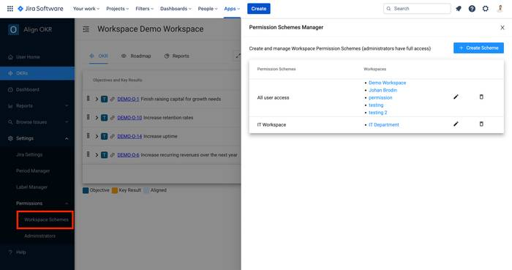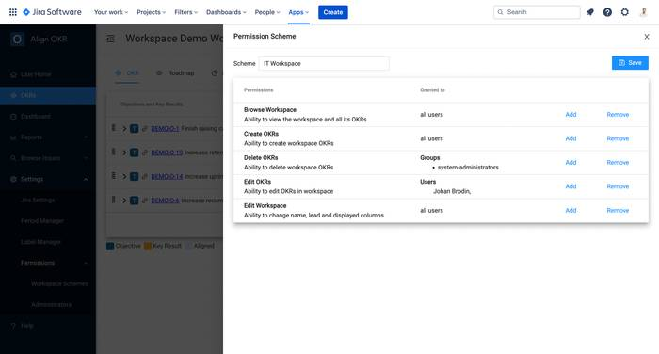

Permission Limitations
BOJA OKR permissions limit user access to app functionality through the BOJA OKR user interface. Permissions are not checked at the database level so Atlassian logged-in users with access to the Jira instance might through “hacking“ and direct API calls gain access.
Please note that access to Jira and monday.com data is protected by those build in permissions.

User Management
- Jira User Management
- monday.com User Management
- Web User management

Jira - User Management
By default all Jira users can directly launch the app and start working with OKRs. This means that there is no additional work or configuration to add users to Align OKR.
If users access needs to be restricted please use the Jira global permission “Align OKR Access“ as described in the permission section.

monday.com - User Management
All monday users with the exceptions of viewers and guest can launch the app from the monday board view.
Those viewers are also available within the solution assigning owners to OKRs, linked monday.com items and workspaces.

Web - User Management
In settings select “User Manager“. Users can be added, inactivated and modified including permission change.
- Add Users
- Remove Users
- User Roles
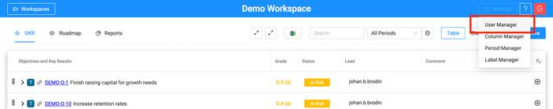

Add Users
Press the “Add User“ button. Then enter the user email address and press “Invite User“. A welcome email is send out and the user ready to login at https://alignokr.web.app/login. At first time login the user must request a password over email selecting the “Invited User“ tab.
(The welcome email might be blocked by spam filters however its informative so not needed for login)
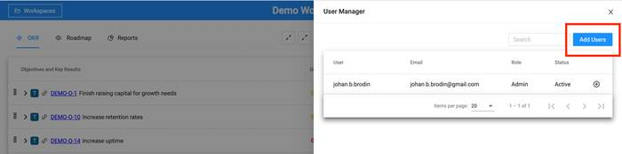
Enter the email address and press “Invite User“
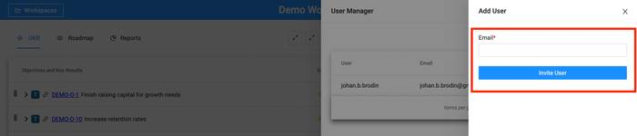
At first login request email password reset under “Invited User“
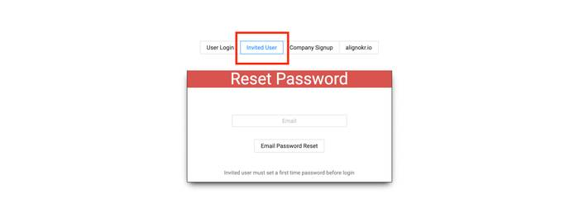

Remove Users
Press the plus button for the user that shall be removed. Select “Disable User“ and the user is not able to login. The user can be enabled at a later point in time.
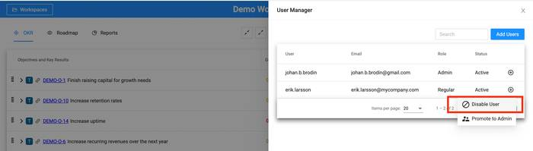

User Roles
There are four different user roles. Different roles can be assigned to different permissions in the workspace permission scheme. Admin users are also allowed to enable the “Admin permission“ restricting or granting actions such as “Delete a Workspace”.
- Regular
- Lead
- Viewer
- Admin

Security and Privacy
Boja OKR are part of the Atlassian “Cloud Security Participant“ program. This means that independent security researchers are invited to find security weaknesses with SLA too correct issues found.
Security and Privacy Policy
- Atlassian Marketplace Security & Privacy
- Boja OKR Security
- Boja OKR Privacy Policy

Miscellaneous
- OKR by BOJA Jira Pro Version

OKR by BOJA Jira Pro Version
OKR by BOJA Jira Pro version enables below features
Feature | Explanation
Grade OKR progress in Percent Binary and Number | Set individual OKR grading in both manual and automatic mode
Restore deleted OKRs from Bin | Restore deleted OKRs from bin (info)
Jira issue view OKR widget | Manage OKRs directly from Jira issue view (info)
Jira issues as objective | Work entirely with Jira issues as both Objective and Key Results
Email notifications | Email notification on OKR activity (info)
Private workspaces | Work in private workspaces and invite collaberators (info)
Custom reports | Create custom reports base on individual OKRs or Workspaces (info)
Custom fields | Add custom fields OKR (info)
OKR Explore | View and edit all OKRs in one place (info)

